Exercise 2: Protocol Exploration & Local REST APIs

Step 2: Design Node-RED for HTTP Requests and Responses
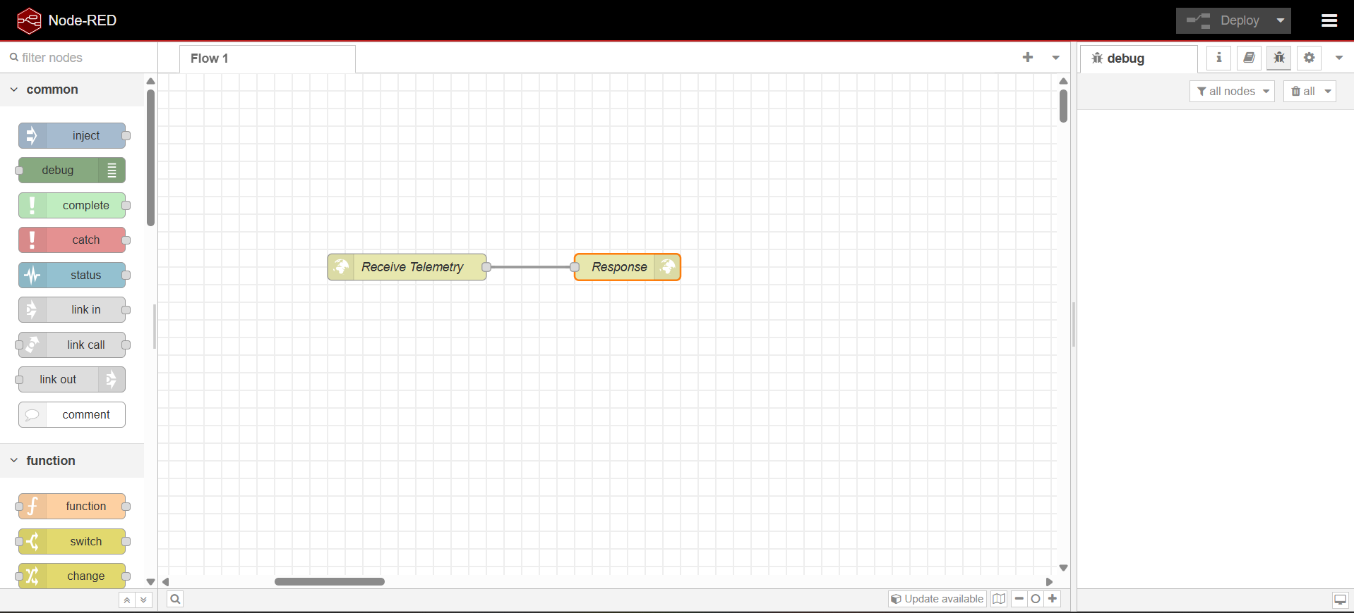

Step 3: Test the Endpoint using Postman
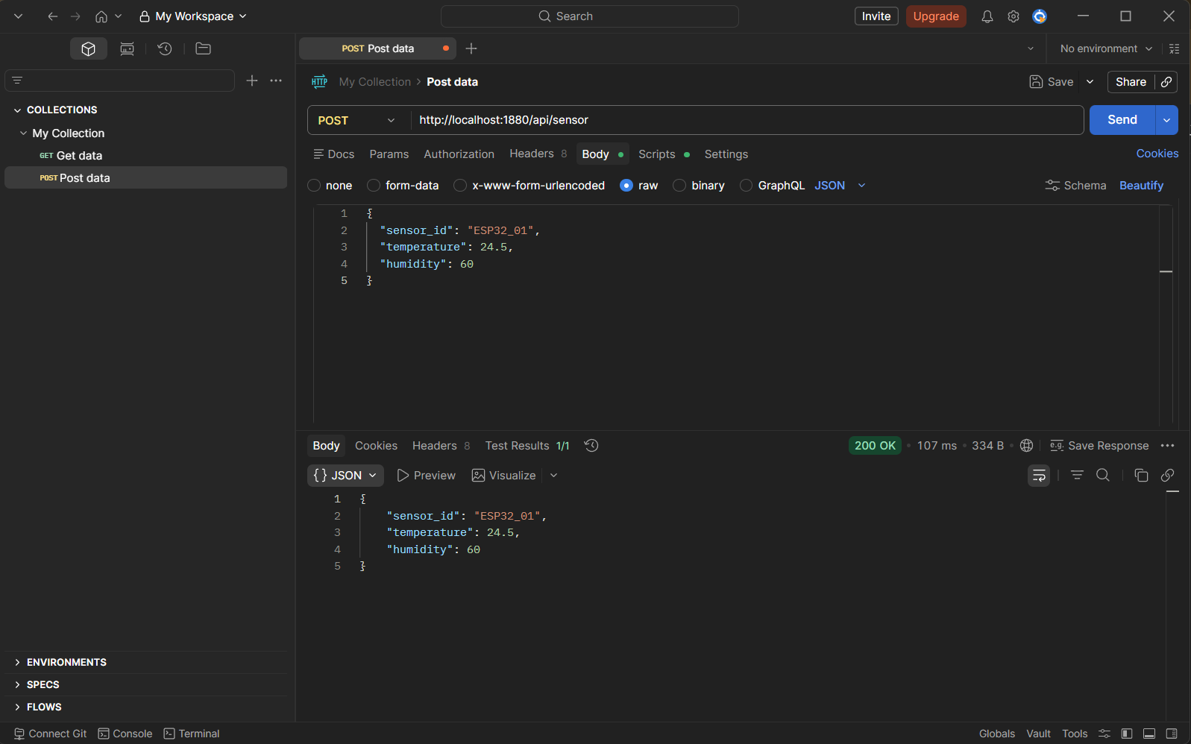

Step 4: Debugging the Node-RED Flow
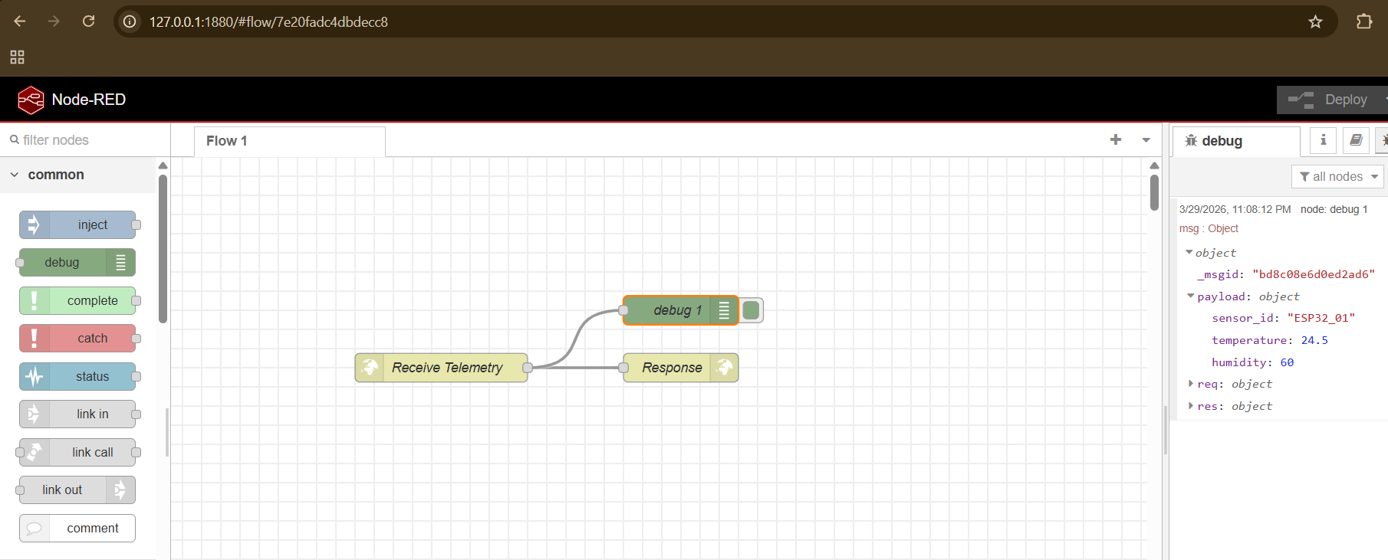

Discussion
A: HTTP Method
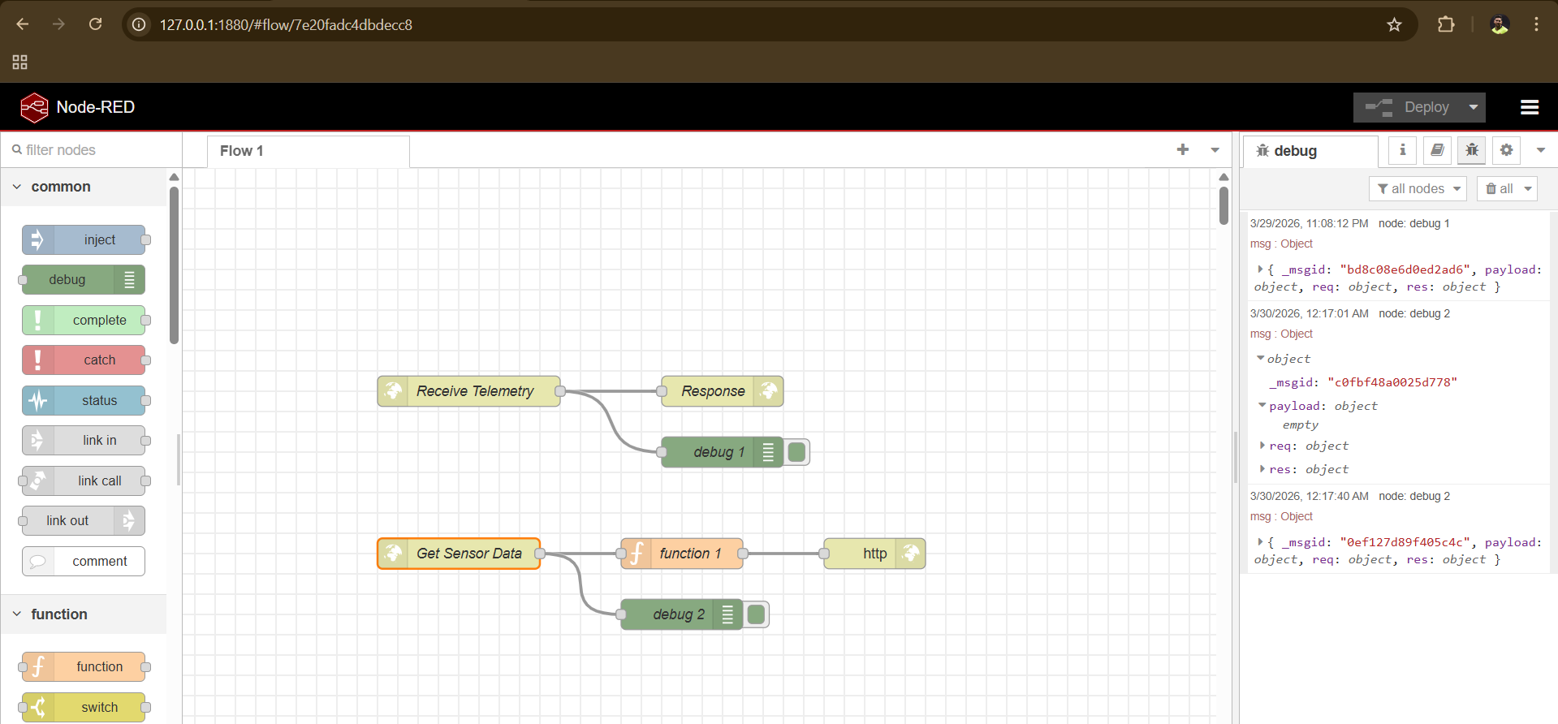
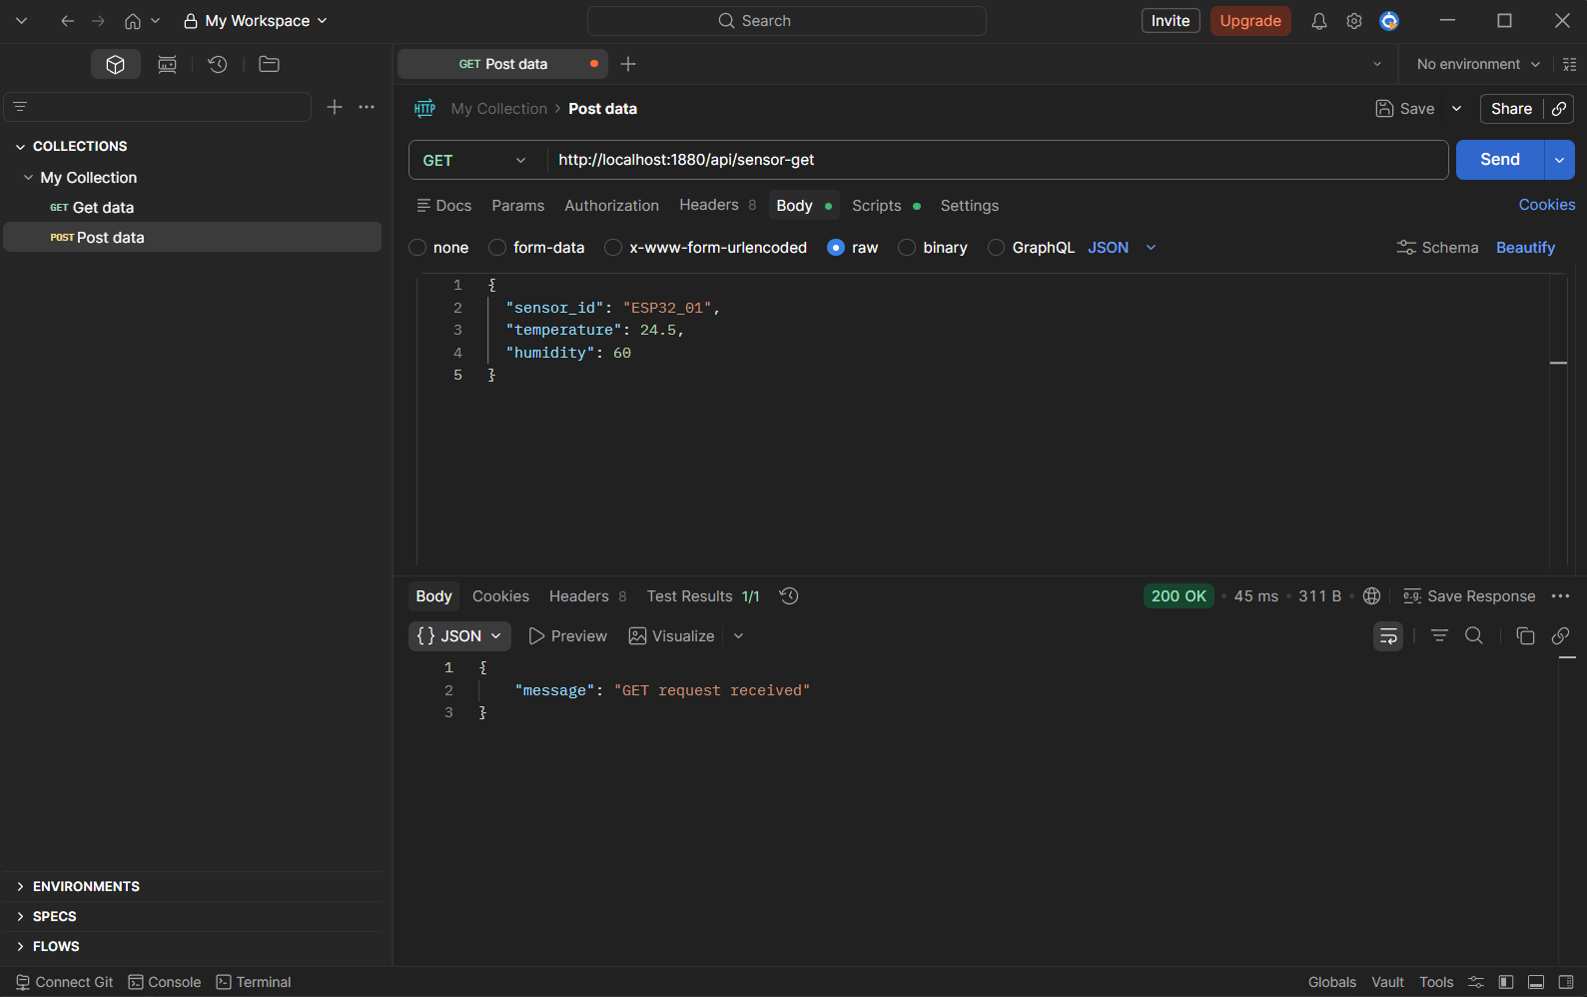

When the request method was changed from POST to GET, the JSON payload was no longer transmitted to the Node-RED server. In the POST request, the sensor data was successfully sent in the request body and displayed in the debug window as a complete JSON object. However, when using a GET request, the payload was not included because GET requests do not support sending data in the request body. As a result, Node-RED did not log the temperature or sensor data in the debug panel for the GET request.
The fundamental difference between POST and GET is that POST is designed to send data to the server in the request body, making it suitable for transmitting structured data such as JSON. In contrast, GET is used to retrieve data from the server and typically sends parameters through the URL instead of the body. Therefore, POST can carry complex payloads, while GET cannot, which explains why the JSON data was not received in the GET request.

B: Local Area Network (LAN) Edge Connectivity
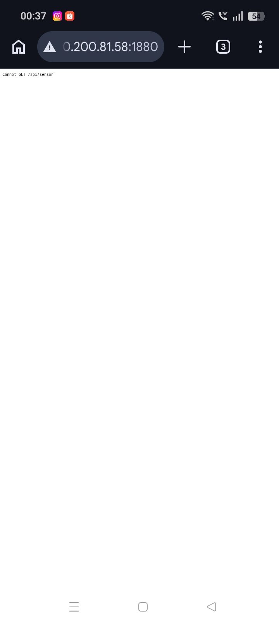
The smartphone was able to access the Node-RED endpoint using the local IPv4 address, which confirms that the Docker container is successfully exposed to the local network. However, the browser on the smartphone could only send a GET request, not a POST request with a JSON payload. This is because standard web browsers are limited to sending GET requests through the address bar and do not support sending structured data in the request body. Therefore, while the endpoint was reachable, it was not possible to transmit sensor data using a POST method from the browser.
C: Deep Packet Inspection via Debugging
Differences between A (GET) and B (LAN test)
- In Activity A (GET request):
  - No JSON payload is present
  - msg.payload is empty or undefined
  - Only request metadata (headers, URL, method) is visible
- In Activity B (LAN test from phone):
  - The request originates from a different IP address (the phone)
  - Still no JSON payload because the browser sends a GET request
  - The debug output confirms external device connectivity via the local network

Conclusion
The debug inspection shows that POST requests include structured JSON data in the payload, while GET requests do not carry a body. Additionally, the remoteAddress field helps identify the source of the request, proving whether it originates from localhost or another device on the same network.

